AI BlogNest - Generate high-quality blog content using AI.
INTRODUCTION
- Project Title : AI BLOGNEST
- Team id : SWTID-2026-4498
- Team Leader : Mizba Tabasum G
E-mail :mizbatabasum077@gmail.com
Team Members :
- Monika M :monikamuthu2804@gmail.com
- Monisha K : monishak262007@gmail.com
- Nandhini G :nandhin2026@gmail.com

Description
ContentGen is a modern, secure, and scalable REST API backend developed to streamline blog creation, content management, and AI-assisted content generation. Built using Node.js and Express.js, the system uses MongoDB with Mongoose to provide efficient data storage, schema management, validation, and reliable database operations.
The platform incorporates Google Gemini AI to enhance the content creation process through intelligent features such as AI-based blog generation, FAQ assistance, WeatherWise insights, and FitTrack recommendations. These capabilities help users generate relevant and personalized content quickly while reducing manual effort.
Scenario-Based Case Study

Background
Priya is a content creator who manages multiple blogs but struggles to organize posts, schedule publications, manage categories/tags, and track reader engagement efficiently.

Problem
- Difficulty managing multiple drafts, categories, and tags.
- Limited visibility into post performance and engagement analytics.
- Time-consuming processes for content approval and comment moderation.
- No streamlined system for handling media uploads or metadata.
- Lack of collaborative permission tiers for editors, authors, and administrators.

SOLUTION

The ContentGen backend provides a centralized and secure REST API that separates core business operations from frontend applications. It manages content workflows, user permissions, media information, categories, and other CMS operations through well-structured backend services. A role-based permission system ensures that each user can access only the features and resources appropriate to their role.

Usage
Author Usage:
Authors can create and manage blog posts, organize drafts, add categories and tags, manage media information, and monitor the performance of their published content.
Editor/Admin Usage:
Editors and administrators can access secured endpoints to review and manage submitted content, update publication status, moderate comments, manage categories, and control user roles and permissions.
Reader Usage:
Readers can access publicly available blogs, search and browse content, view posts, and submit comments through authorized API endpoints.

Outcome
The backend centralizes content workflows and access control, making the overall system more organized, secure, and efficient. Schema validation helps maintain consistent and reliable data, while authentication and role-based authorization prevent unauthorized operations. Centralized logging and structured data management also provide useful information for monitoring content activity and evaluating blog performance.

1. Software Requirements
- Operating System: Windows 10/11, macOS, or Linux (supports cross-platform operations).
- Node.js (v16 or above): Runtime ecosystem running server logic and routing infrastructure.
- npm (v8 or above): Node package manager to control operational dependencies.
- Express.js: Lightweight routing web framework to construct backend RESTful entry points.
- MongoDB: Document NoSQL engine storing users, posts, categories, comments, and analytics metrics.
- Postman: API verification toolkit to assert schema validation responses across administrative route shields.
- Code Editor: Visual Studio Code or similar IDE environment.

2. Hardware Requirements
- Processor: Intel Core i5 (8th Gen or above) / AMD Ryzen 5 or equivalent.
- RAM: 8 GB minimum (16 GB recommended for concurrent instances of MongoDB, processing layers, and execution nodes).
- Storage: 1 GB of available disk workspace.

Epic:-1 PROJECT ARCHITECTURE
System Architecture
The ContentGen application follows a layered backend architecture in which incoming API requests pass through multiple processing stages before reaching the appropriate business logic and database services. This structure improves maintainability, security, and separation of responsibilities.

Component Definitions
1. API Interface
Tools such as Postman interact with the backend through defined API endpoints. Requests are sent to specific routes, and the server returns structured JSON responses containing the requested information.
2. Express.js Server Layer
The Express server acts as the primary entry point for client requests. It manages network communication, handles HTTP methods such as GET, POST, PUT, and DELETE, processes JSON request bodies, manages CORS policies, and forwards requests to the appropriate controllers.
3. Authentication and Authorization Middleware
This layer verifies authentication tokens supplied through request headers. JWT authentication is used to validate the user's identity, while role-based authorization determines whether the user has sufficient privileges to access protected resources.
4. Business Logic Services
Dedicated service modules manage the application's core operations. These modules handle different stages of the blog lifecycle, including Draft, Pending Approval, Scheduled, and Published states. They also manage comment moderation, user operations, and system-level reporting functions.
5. Database Access Layer
The Mongoose ODM provides the connection between application logic and MongoDB. It manages schemas, validation, and database operations while converting application requests into efficient MongoDB queries.
6. AI Integration Layer
The AI service layer adds intelligent content-generation capabilities to the application. It supports functions such as automated blog generation and content summarization through dedicated endpoints like /api/ai/generate-blog and /api/ai/summarize. These services connect the backend with external AI models, allowing complex text-processing tasks to be handled separately from the core application logic.

Overall Flow
Client/Postman → Express Server → Authentication & Authorization → Controllers/Services → Mongoose → MongoDB
For AI-based operations:
Client → Express Server → AI Controller → AI Service → External AI Model → JSON Response

Entity-Relationship (ER) Diagram Description
The underlying document structure manages several collections bound by logical application references:
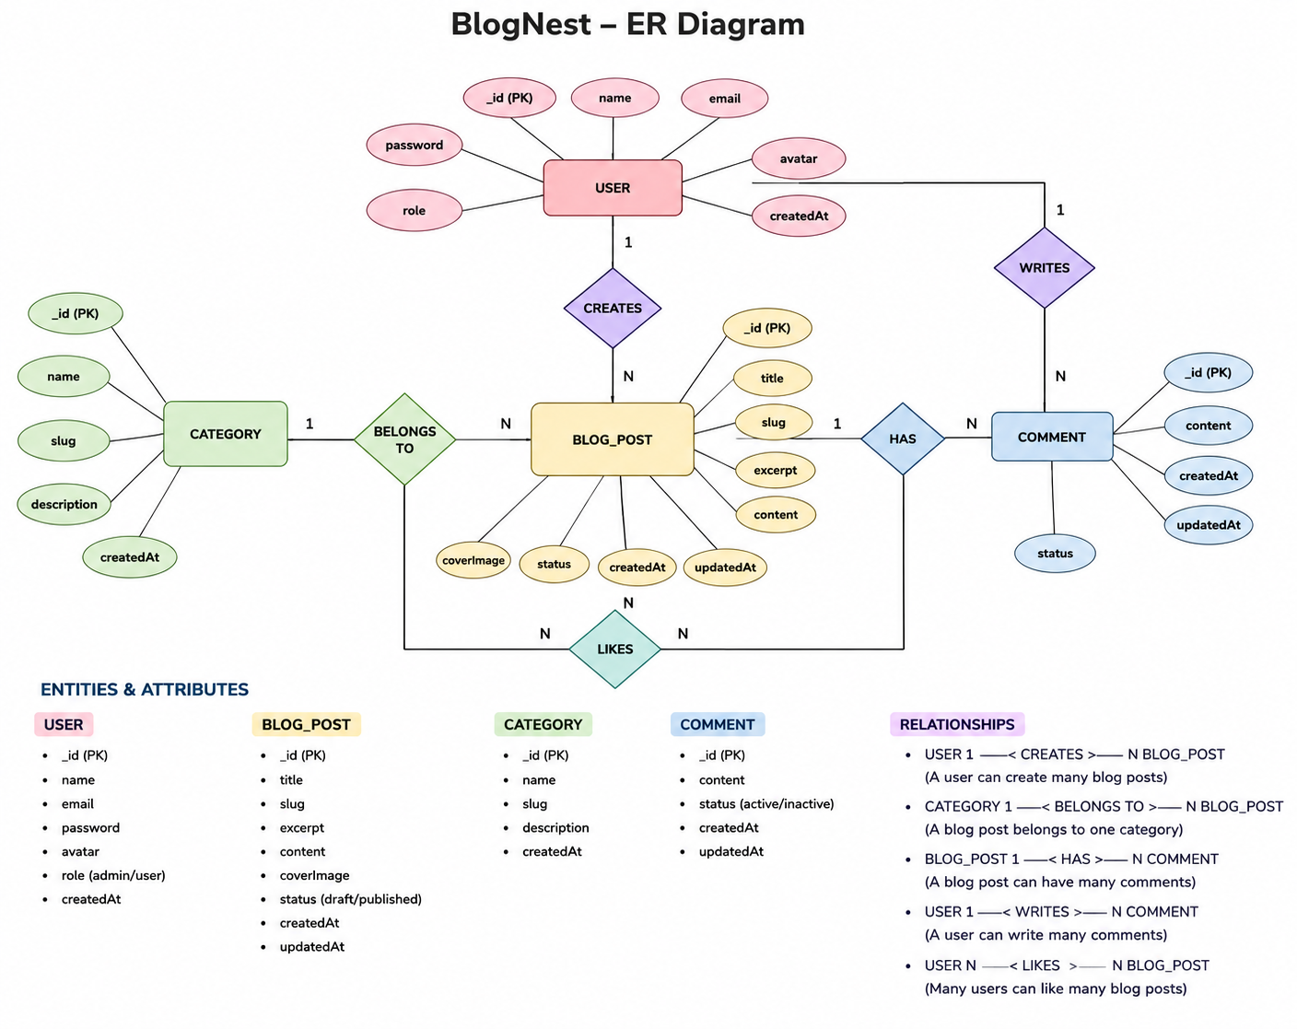1. User Entity
The User Entity stores authentication details, personal information, and access permissions for each registered user.
- _id – Primary key generated as a MongoDB ObjectId
- name – User's name (String, Required)
- email – Unique email address used for identification and authentication (String, Required, Unique)
- password – Encrypted/hashed user password (String, Required)
- role – Defines the user's access level (String, Default: "reader")

2. Post Entity
The Post Entity represents blog articles created and managed within the ContentGen platform.
- _id – Primary key generated as a MongoDB ObjectId
- title – Title of the blog post (String, Required)
- content – Main body of the blog post (String, Required)
- author – Reference to the user who created the post (ObjectId, Required)
- category – Category assigned to the post (ObjectId)
- tags – Collection of tags associated with the post (Array)
- status – Current publishing state of the post (String, Default: "draft")
- featuredImage – Reference or path to the post's featured image (String)
- createdAt – Date and time when the post was created
- updatedAt – Date and time when the post was last modified
- userID – Foreign key referencing the User Collection, identifying the user who submitted the comment.
- name – Commenter's name or display title (String, Required).
- photo – Profile image reference or image pathway (Object/String).
- message – Main content of the comment (String).
- likes – Number of likes received by the comment (Number, Default: 0).
- timestamps – Automatically records the comment's creation and last update time (True).

Key Structural Relationships
- User to Post – One-to-Many: A single author can create and manage multiple blog posts.
- User to Comment – One-to-Many: A registered user can submit multiple comments across different blog posts.
- Post to Comment – One-to-Many: Each blog post can have multiple comments associated with it.

Key Features
1. Role-Based Access Control
JWT authentication and role-based authorization ensure that only users with the required permissions can access protected resources or modify restricted system settings.
2. Blog CRUD Management
The system supports complete Create, Read, Update, and Delete (CRUD) operations for blog posts, including content details, publishing status, categories, tags, and associated media.
3. Categorization and Tagging
Categories and tags help organize blog content and make posts easier to filter, search, and discover.
4. Comment Moderation
Authorized users can manage comments through protected endpoints and assign moderation states such as Pending, Approved, or Spam.
5. Input Sanitization and Security
User-provided input is validated and sanitized to reduce security risks such as Cross-Site Scripting (XSS) and malicious database query manipulation.
6. AI-Powered Blog Generation
The system integrates Large Language Model (LLM) services with context-aware prompts to automatically generate structured blog content from user-provided topics or ideas.
7. Intelligent Content Summarization
The AI service analyzes lengthy content and generates concise summaries, abstracts, and supporting metadata, making large articles easier to understand and manage.

Roles and Responsibilities
Admin:
Has the highest level of system access. Administrators can manage users, assign or modify roles, moderate or remove inappropriate comments, and review system activity and logs.
Primarily consumes published content. Readers can browse and read available blog posts and, where permitted, submit comments using their authenticated accounts.

User Flow
The overall user interaction follows a controlled sequence:
User Registration/Login → JWT Authentication → Role Verification → Authorized API Access → Business Logic Processing → Database Operation → JSON Response
For AI-assisted content creation:
Author → Blog Generation Request → AI Service → LLM Processing → Generated Content → Review/Edit → Save as Draft or Publish


MVC Architecture Pattern
The system architecture structures its source configuration layers around the Model-View-Controller design pattern to completely decouple components: 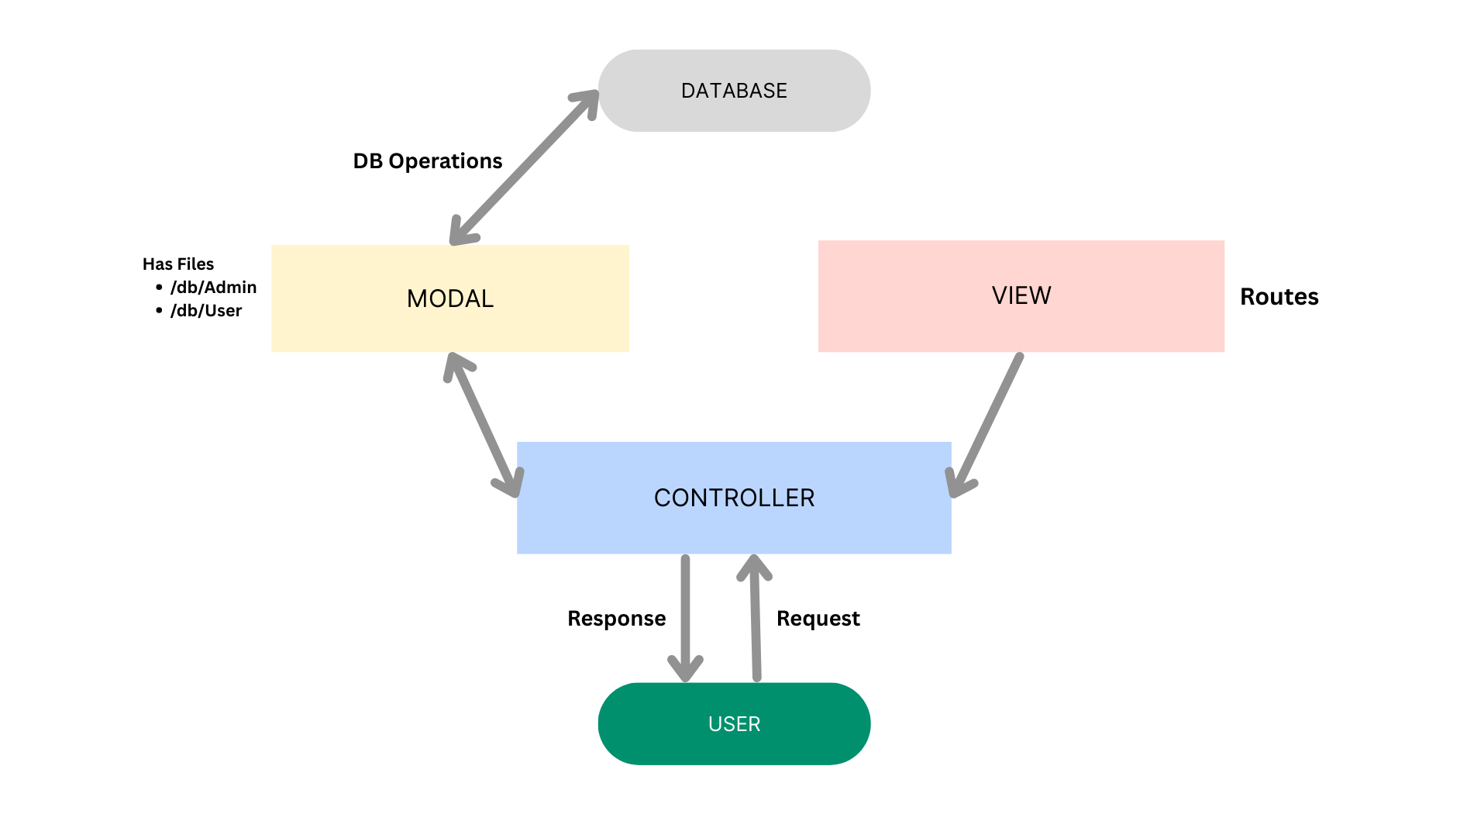

Application Architecture Layers

1. Model Layer – Data Structure
The Model Layer defines the application's data structure using Mongoose schemas. It specifies fields, data types, validation rules, default values, indexes, and relationships before information is stored in MongoDB. This layer ensures that database records remain consistent, structured, and reliable.

2. Controller Layer – Business Execution
The Controller Layer acts as the bridge between API requests and application logic. It receives requests from the routing layer, validates the required input, invokes the appropriate services or database models, processes the results, and returns standardized JSON responses to the client.

3. View Layer – API Interface
Since ContentGen is a headless backend application, it does not use traditional frontend view templates such as HTML or server-rendered pages. Instead, the API Routing Layer serves as the interface between clients and the backend. It maps HTTP requests to the appropriate controller functions and provides structured responses that can be consumed by web, mobile, or other client applications.

Architecture Flow
Client → API Routes → Controllers → Services/Models → MongoDB → JSON Response

Epic2: Project Setup and Configuration
Creating project folder

1. Create a new folder with your <project name>.
2. Inside that folder create one new folders.
3. Name another one as Server.
4. Now open that folder in VS Code.

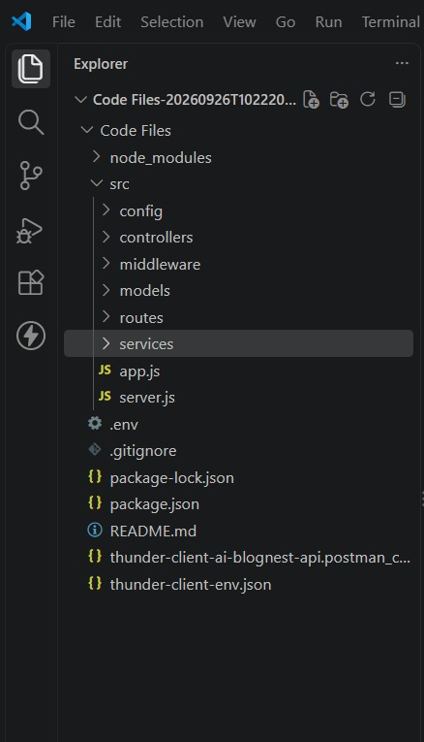
Server setup (npm init)
- Open Server folder in terminal of VScode.
- npm init -y
- Create files:
- server.js
- Create folders:
- Models
- controllers
- routes

Epic 3: Backend Development
Server.js
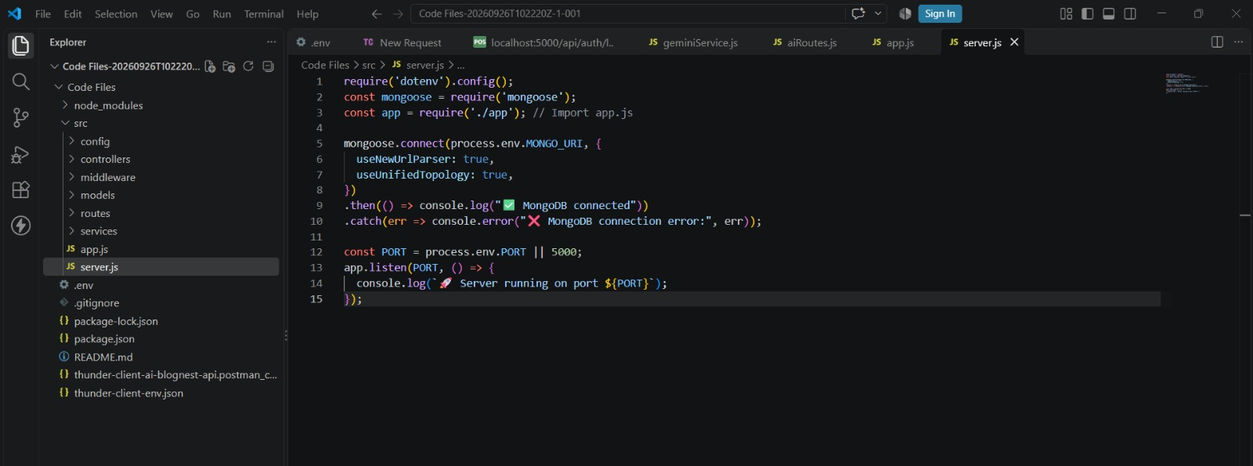
App.js
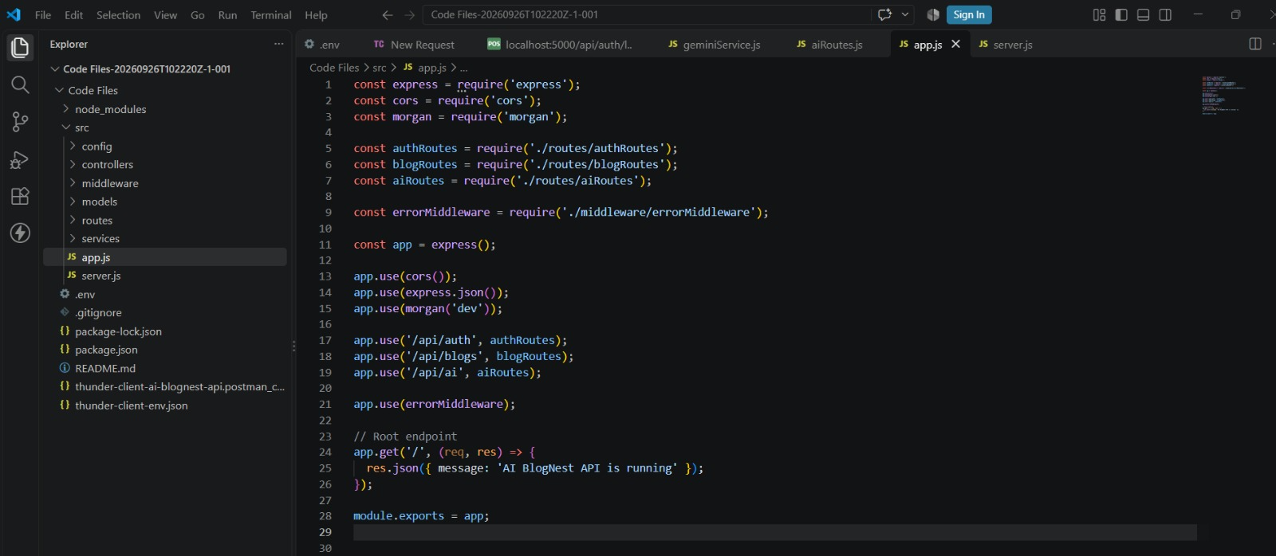

Epic4: Database Configuration
DB Connection:-

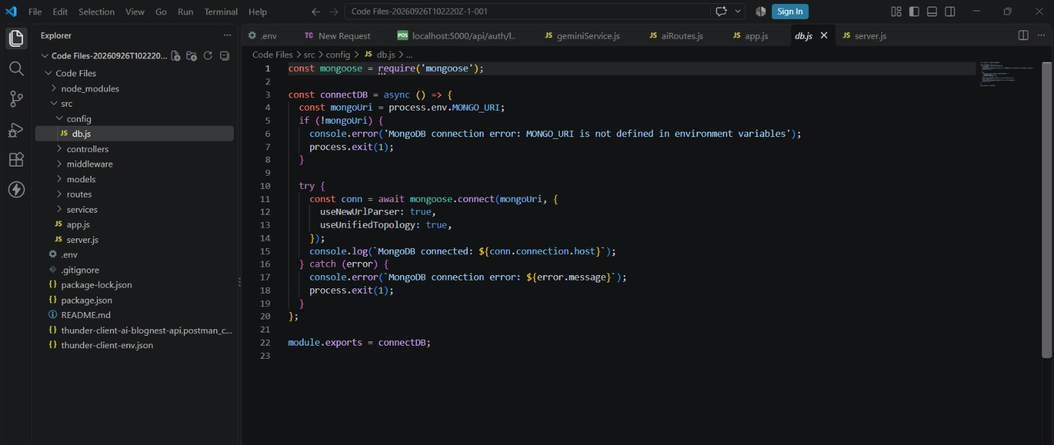
1. Configure MongoDB:

- Install Mongoose.
In your Node.js project directory, run:
npm install mongoose
- Create database connection.
- Create Schemas & Models.

Create Database connection:
Now, make sure the database is connected before performing any of the actions through the backend. The connection code looks similar to the one provided below

Mongoose Schema Definitions

1. Identity Resource Document Schema (schemas/userModel.js)
Enforces field criteria validations on incoming database creations:
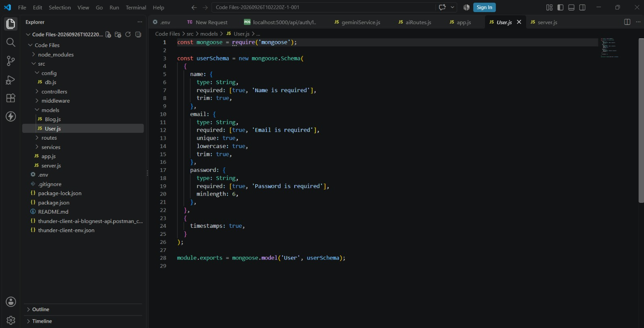

Epic 5: Project Executions:
· Install Postman or ThunderClient (VS Code extension).

· Start the backend server:
“npm start”

API Testing

User Registration :
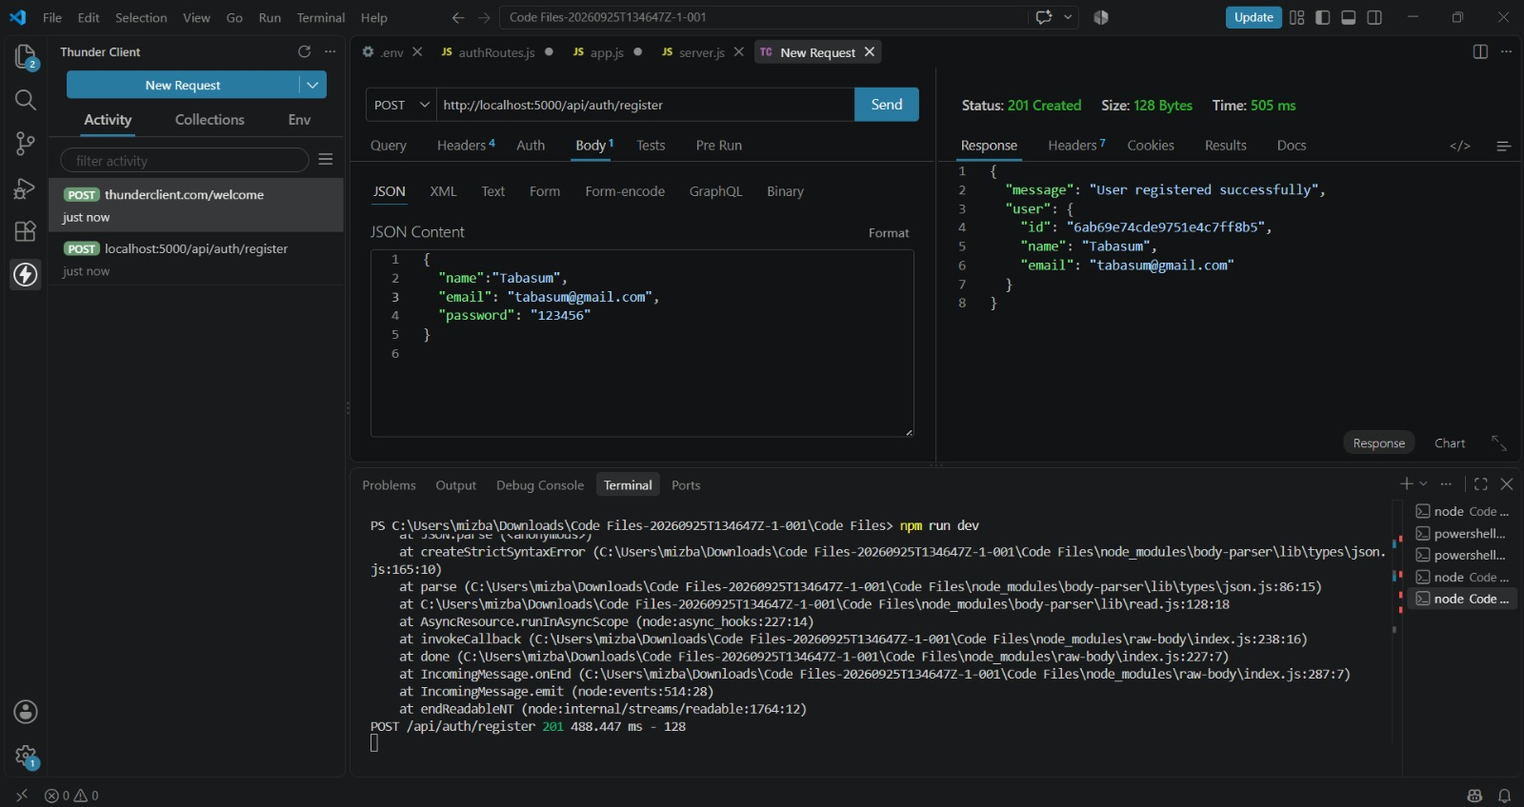

User Login:
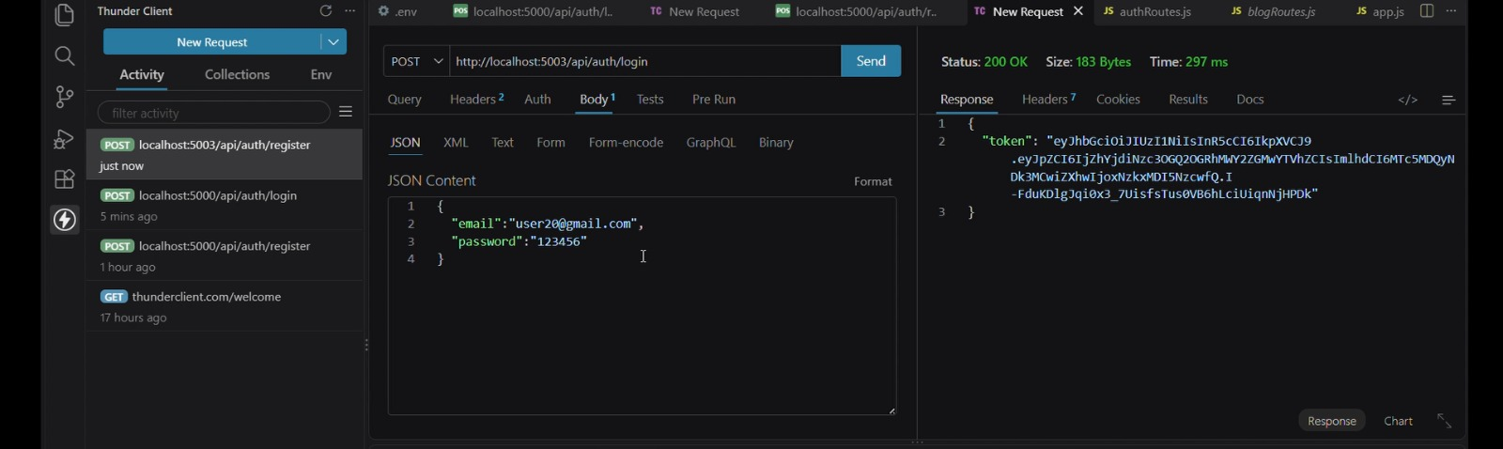

Create Blogs :
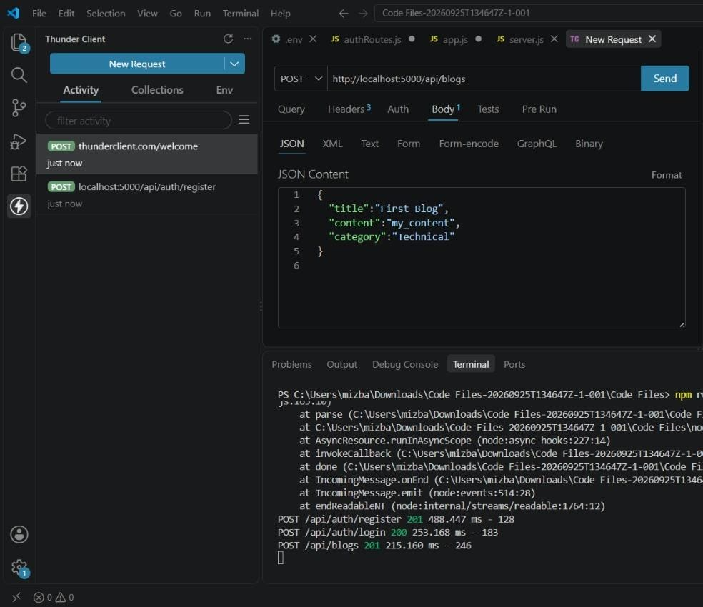

Fetch Blogs :
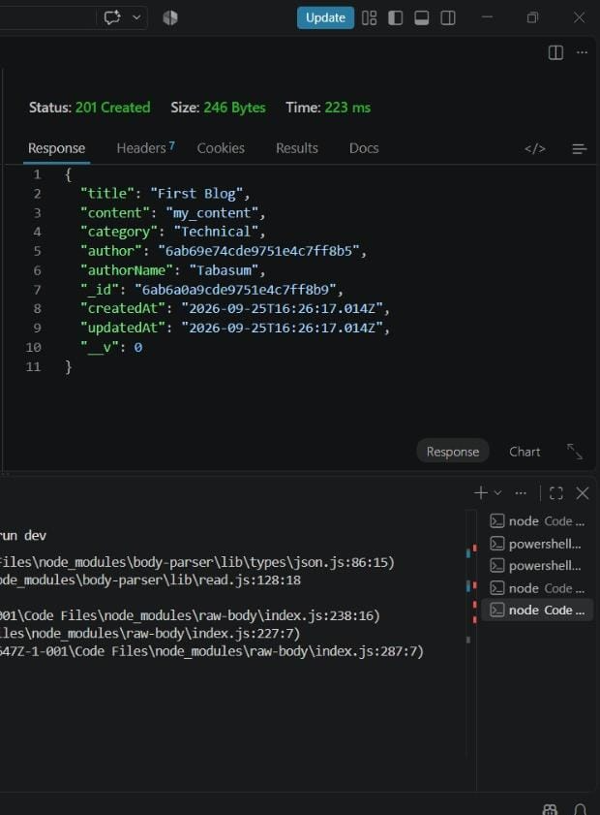

Generate AI blogs :
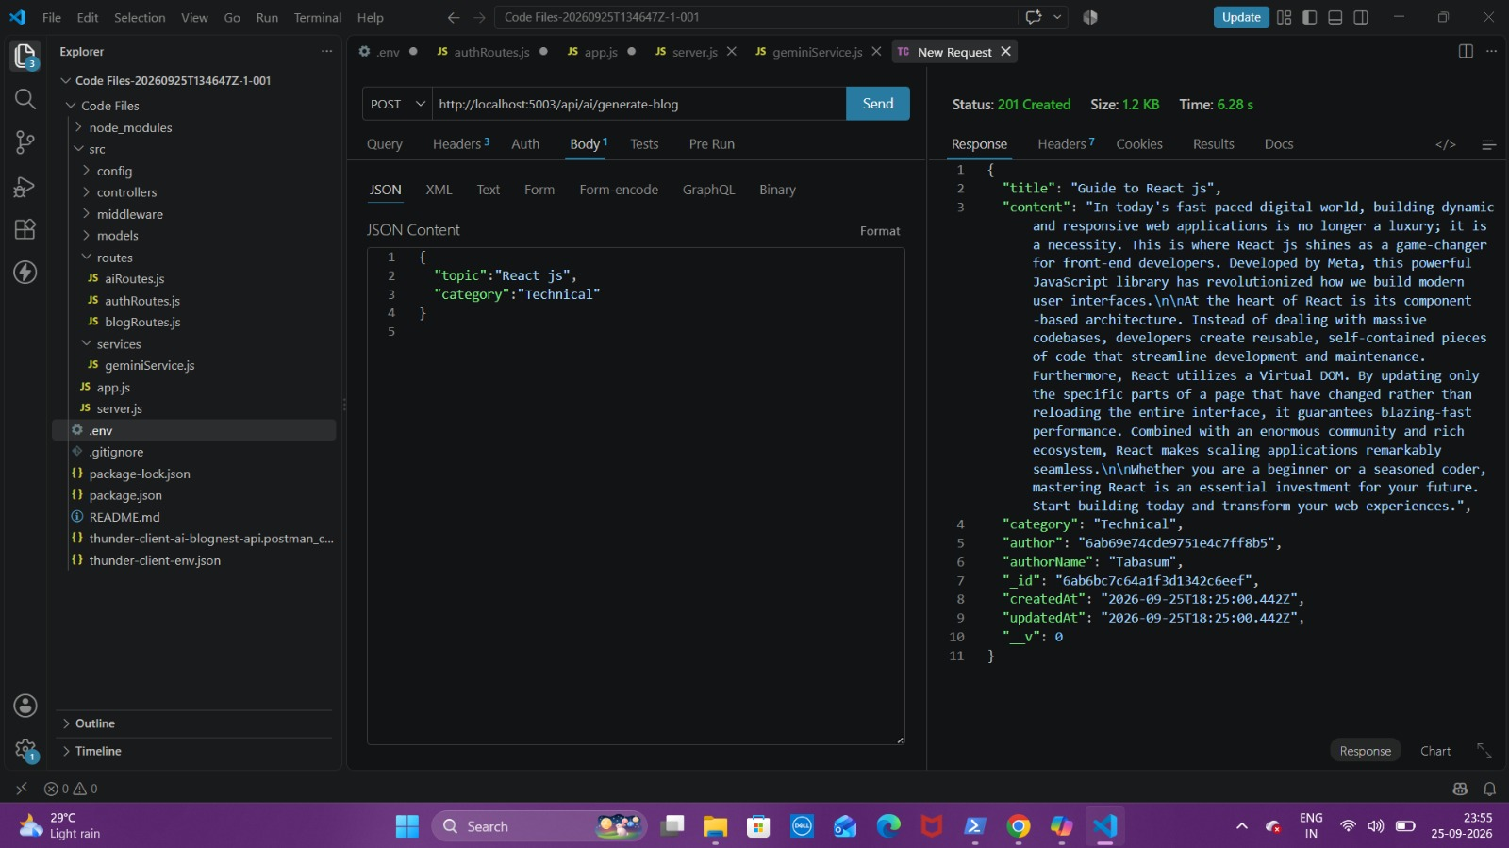
Summarize Blogs :
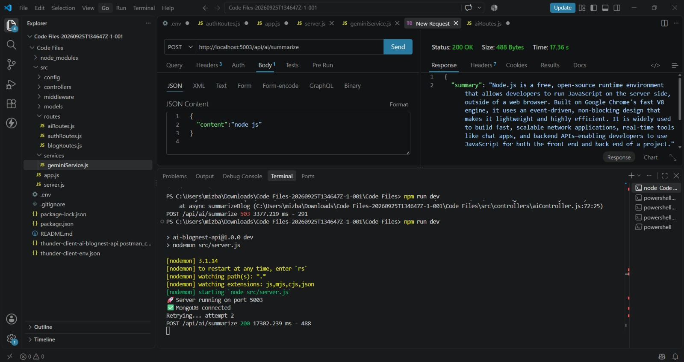

Demo Video : https://drive.google.com/file/d/1wBIcCxDVwPmMA3XwFWGiWn223LNnAjLh/view?usp=sharing

Code: https://drive.google.com/drive/folders/1UjD4f-3upKeGXhOEwFL3JcK5cw-UK8Jz?usp=sharing
API Testing : API testing Video

